VISVESVARAYA TECHNOLOGICAL UNIVERSITY
Jnana Sangama, Belagavi-590018, Karnataka

A TECHNICAL SEMINAR REPORT (18CSS84) ON
“DEEP LEARNING & FUSION TECHNIQUES”
Submitted in Partial fulfillment of the Requirements for the Degree of
Bachelor of Engineering in Artificial Intelligence & Machine Learning
By
Kenesha Watt Q(1CR23AI045)
Allie Thakur (1CR23AI003)
Syed Anshu (1CR23AI408)
Under the Guidance of,
Ms. Sandhya Kumari
Assistant Professor, Dept. of AIML


DEPARTMENT OF ARTIFICIAL INTELLIGENCE AND MACHINE LEARNING
CMR INSTITUTE OF TECHNOLOGY
#132, AECS LAYOUT, IT PARK ROAD, KUNDALAHALLI, BANGALORE-560037
CMR INSTITUTE OF TECHNOLOGY
#132, AECS LAYOUT, IT PARK ROAD, KUNDALAHALLI, BANGALORE-560037

DEPARTMENT OF ARTIFICIAL INTELLIGENCE AND MACHINE LEARNING

CERTIFICATE
This is to certify that the Seminar entitled “Deep Learning & Fusion Techniques” carried out by Allie Thakur(1CR23AI003), Kenesha Watt Q(1CR23AI045), Syed Anshu(1CR24AI408), bonafide student of CMR Institute of Technology, Bengaluru, in partial fulfillment for the award of degree of Bachelor of Engineering in Computer Science and Engineering of the Visvesvaraya Technological University, Belagavi during the academic year 2026-27. It is certified that all corrections/suggestions indicated for Internal Assessment have been incorporated in the Report deposited in the departmental library.
The seminar report has been approved as it satisfies the academic requirements in respect of Technical Seminar prescribed for the said Degree.

.
________________  Ms. Sandhya Kumari  Assistant Professor  Dept. of AIML, CMRIT |  | ________________  Dr. Shyam P Joy  Associate Professor & HOD  Dept. of AIML, CMRIT

CMR INSTITUTE OF TECHNOLOGY
#132, AECS LAYOUT, IT PARK ROAD, KUNDALAHALLI, BANGALORE-560037

DEPARTMENT OF ARTIFICIAL INTELLIGENCE AND MACHINE LEARNING

DECLARATION

I, Allie Thakur(1CR23AI003), Kenesha Watt Q(1CR23AI045), Syed Anshu(1CR24AI408), bonafide students of CMR Institute of Technology, Bengaluru, affiliated to Visvesvaraya Technological University, Belagavi., hereby declare that the entire seminar work entitled “Deep Learning & Fusion Techniques” has been carried out by me during VIII semester of degree of Bachelor of Engineering in Artificial Intelligence And Machine Learning at CMR Institute of Technology, Bengaluru during the academic year 2022-23 under the esteemed guidance of Guide name , Designation, Dept. of AIML, CMRIT, Bengaluru . The report is original, and it has not been submitted in part or full for any other degree in any University.
NAME | USN | SIGNATURE
Kenesha Watt Q | 1CR23AI045
Allie Thakur | 1CR23AI003
Syed Anshu | 1CR24AI408

Place: CMRIT, Bengaluru
Date: 19 May 2026

ABSTRACT

Multimodal Emotion Recognition (MER) is an AI-driven approach that identifies human emotional states by integrating multiple signal sources, audio, video, text, and physiological data. Unlike unimodal systems, MER leverages complementary modalities to achieve significantly higher accuracy and robustness in real-world conditions. This seminar examines deep learning architectures including CNN, LSTM, BERT, and Transformers, alongside fusion strategies such as early, late, and hybrid fusion. Key challenges including missing modalities, cross-domain generalization, and computational constraints are discussed. Applications span healthcare, education, robotics, and autonomous vehicles, with future directions toward explainable AI and multimodal large language models.

ACKNOWLEDGEMENT

We take this opportunity to express my sincere gratitude and respect to CMR Institute of Technology, Bengaluru for providing me a platform to pursue my studies and carry out my technical seminar.
We have a great pleasure in expressing my deep sense of gratitude to Dr. Sanjay Jain, Principal, CMRIT, Bangalore, for his constant encouragement.
We would like to thank Dr. Shyam P Joy, Associate Professor and Head, Department of AIML, CMRIT, Bangalore, who has been a constant support and encouragement throughout the course of this seminar.
We consider it a privilege and honor to express my sincere gratitude to my guide,
Ms. Sandhaya Kumari, Assistant Professor, Department of AIML, for the valuable guidance throughout the tenure of this seminar.
We also extend my heartfelt thanks to all the faculty members of Dept. of AIML who directly or indirectly encouraged me.
Finally, we would like to thank my parents and friends for all their moral support they have given me during the completion of this work.

TABLE OF CONTENTS
 | Page No.
Certificate | ii
Declaration | iii
Abstract | iv
Acknowledgement | v
Table of contents | vi
List of Figures | viii
List of Tables | ix
List of Abbreviations | x
- INTRODUCTION  - Overview  - Domain of Multimodeal Emotion Recongintion  - Recent Developments  - Chapter-Wise Summary | 1
- SURVEY OF CHANGES IN TECHNOLOGY  2.1 Early Unimodal Systems (Pre-2010)  2.2 Rise of Multimodal Approaches and Deep Leaning(2010-2018)  2.3 Transformer Era and Pre-trained Models (2018–2023)  2.4 State of the Art: XAI and Reinforcement Learning (2024–2025)  2.5 Comparison and Inferences | 5
- DISCUSSION OF TECHNOLOGY  3.1 Feature Extraction Techniques  3.2 Fusion Techniques  3.3 Deep Learning Models  3.4 Explainable AI in MER | 9
- IMPACT ON SOCIETY, ENVIRONMENT AND DOMAIN  4.1 Impact on Society  4.2 Impact on Environment  4.3 Impact on the Domain of HCI and AI  4.4 Ethical Considerations | 14
- CONCLUSION AND FUTURE WORK  5.1 Conclusion  5.2 Future Scope | 16
REFERENCES | 18

LIST OF FIGURES

 | Page No.
Fig 1.1 Ekman's Six Basic Emotions used as Classification Categories in MER | 2
Fig 2.1 Timeline of Key Developments in MER (2008–2025) | 6
Fig 3.1 MFCC Spectrogram of an Emotional Speech Utterance: Anger vs. Neutral | 8
Fig 3.2 68-Point Facial Landmark Model for Action Unit Detection | 9
Fig 3.3 Early Fusion Architecture: Feature-Level Concatenation Before Classification | 10
Fig 3.4 Late Fusion Architecture: Independent Modality Classifiers with Score Combination | 10
Fig 3.5 End-to-End MER Pipeline: Feature Extraction, Temporal Modelling, Fusion | 12
Fig 4.1 MER Deployment in a Healthcare Passive Monitoring Workflow | 14

LIST OF TABLES

 | Page No.
Table 1.1 Summary of Unimodal vs Multimodal Emotion Recognition Approaches | 2
Table 2.1 Chronological Comparison of Key MER Research Contributions | 7
Table 3.1 Comparison of Fusion Strategies in Multimodal Emotion Recognition | 11

LIST OF ABBREVIATIONS

Abbreviation | Full Form
AI | Artificial Intelligence
AU | Action Unit
BERT | Bidirectional Encoder Representations from Transformers
BVP | Blood Volume Pulse
CNN | Convolutional Neural Network
CoT | Chain-of-Thought
DL | Deep Learning
ECG | Electrocardiogram
EEG | Electroencephalogram
EMG | Electromyography
FACS | Facial Action Coding System
GRPO | Group Relative Policy Optimization
GSR | Galvanic Skin Response
HCI | Human-Computer Interaction
HOG | Histogram of Oriented Gradients
HRV | Heart Rate Variability
IEMOCAP | Interactive Emotional Dyadic Motion Capture
LLM | Large Language Model
LSTM | Long Short-Term Memory
MER | Multimodal Emotion Recognition
MFCC | Mel Frequency Cepstral Coefficients
ML | Machine Learning
NLP | Natural Language Processing
PTSD | Post-Traumatic Stress Disorder
RAVDESS | Ryerson Audio-Visual Database of Emotional Speech and Song
RL | Reinforcement Learning
RNN | Recurrent Neural Network
SAVEE | Surrey Audio-Visual Expressed Emotion
SHAP | SHapley Additive exPlanations
TF-IDF | Term Frequency-Inverse Document Frequency
ViT | Vision Transformer
VLM | Vision Language Model
VR | Virtual Reality

CHAPTER 1
INTRODUCTION
Emotion recognition has emerged as one of the most transformative research frontiers in artificial intelligence, bridging the gap between human affective experience and machine intelligence. The ability to automatically identify and interpret human emotional states has profound implications across a wide spectrum of applications, ranging from healthcare and education to autonomous vehicles and human-computer interaction (HCI). As digital interfaces become increasingly integrated into daily life, the demand for systems that can understand and respond to human emotions in real time has grown substantially [1].
Traditional approaches to emotion recognition relied on a single data channel — either audio, video, or text — leading to systems that were fragile in the face of noise, occlusion, or data corruption. The paradigm shift towards Multimodal Emotion Recognition (MER) leverages the complementary nature of multiple signal modalities to achieve superior accuracy and robustness. Recent developments in deep learning, particularly Convolutional Neural Networks (CNNs), Long Short-Term Memory (LSTM) networks, and Transformer-based models such as BERT, have dramatically accelerated progress in this domain [2]. This seminar examines the state of the art in MER, the core technologies that underpin it, and the research directions shaping its future.
1.1 Overview
Multimodal Emotion Recognition (MER) is the computational task of detecting and classifying human emotional states by jointly processing signals from multiple sources: acoustic features from speech, visual cues from facial expressions and gestures, semantic content from text transcripts, and physiological signals such as electroencephalogram (EEG) and galvanic skin response (GSR). The motivation for the multimodal approach stems from the way humans naturally perceive emotions — through a simultaneous integration of what is said, how it is said, and the accompanying non-verbal signals [3].
The field of Affective Computing, first formalised by Picard [4] in 1997, laid the conceptual groundwork for emotion-aware machines. Ekman's taxonomy of six basic emotions — happiness, sadness, anger, fear, disgust, and surprise — remains a foundational reference for emotion classification benchmarks. As illustrated in Fig 1.1, these six categories provide the baseline emotional vocabulary used across the majority of MER datasets.
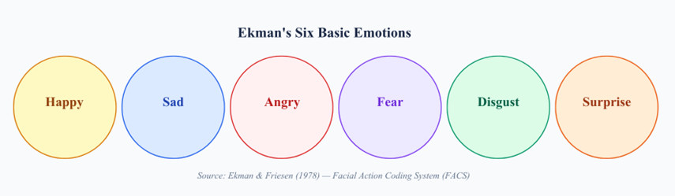
Fig 1.1 Ekman's Six Basic Emotions used as Classification Categories in MER
As can be seen in Fig 1.1, the six basic emotion categories form the core label space for most MER systems. More recent datasets such as CMU-MOSEI extend this space to include compound emotions and sentiment polarity scores, reflecting the nuanced nature of real-world emotional expression.
1.1.1 Domain of Multimodal Emotion Recognition
The domain of Multimodal Emotion Recognition sits at the intersection of signal processing, natural language processing (NLP), computer vision, and affective computing. It draws on techniques from deep learning to extract high-level, abstract representations from raw sensor data across each modality, and subsequently fuses these representations to produce a unified emotion prediction. The domain is characterised by its inherent interdisciplinarity and the challenge of aligning heterogeneous data streams that differ in sampling rate, dimensionality, and temporal granularity [5].
Table 1.1 summarises the key approaches in MER and highlights the distinction between unimodal and multimodal methods in terms of input, typical accuracy, and robustness.
Table 1.1 Summary of Unimodal vs Multimodal Emotion Recognition Approaches
Approach | Input Modality | Typical Accuracy | Robustness
Unimodal Audio | Speech / MFCCs | 60–70% | Low — fails under noise
Unimodal Video | Facial Action Units | 62–72% | Low — sensitive to occlusion
Unimodal Text | Transcripts / Embeddings | 65–75% | Moderate — misses prosody
Multimodal MER | Audio + Video + Text | 75–90%+ | High — modalities compensate

1.2 Motivation for Multimodal Emotion Recognition
The primary motivation for pursuing multimodal fusion over single-channel approaches is robustness. In real-world deployment scenarios, individual modalities are often corrupted or missing: a noisy acoustic environment may render audio features unreliable, while poor lighting or occlusion may degrade video quality. A multimodal system can compensate for degradation in one channel by relying more heavily on the remaining modalities, a property sometimes referred to as graceful degradation [1][2].
A secondary motivation is accuracy. Emotions are inherently multi-channelled phenomena. A speaker may verbally express contentment while their facial micro-expressions and vocal prosody betray underlying anxiety — a phenomenon known as emotional masking. Multimodal systems are better equipped to detect such incongruences and arrive at a more accurate emotional label [3]. Recent state-of-the-art results on the IEMOCAP benchmark confirm this: the R1-Omni model [5], leveraging reinforcement learning and omni-modal fusion, achieved 90.1% accuracy in 2025, far surpassing earlier unimodal baselines.
1.3 Recent Developments
The past five years have witnessed several landmark developments in MER. The widespread adoption of Transformer architectures and pre-trained models such as BERT [6], RoBERTa, and wav2vec 2.0 has dramatically improved feature extraction across text and audio modalities respectively. Cross-modal attention mechanisms have enabled models to dynamically weight the contribution of each modality based on context, while Explainable AI (XAI) tools such as SHAP values and Grad-CAM have begun to address the interpretability gap in black-box deep learning systems [7].
The introduction of the R1-Omni model [5] in 2025 marked a significant milestone: it is the first system to apply reinforcement learning (specifically Group Relative Policy Optimization, GRPO) to end-to-end multimodal emotion recognition, while simultaneously generating chain-of-thought textual explanations for each prediction. This development signals a convergence of MER with the broader trend towards multimodal large language models (LLMs).

1.4 Chapter-Wise Summary
The remainder of this seminar report is organised as follows. Chapter 2 presents a chronological survey of technological developments in MER, from early unimodal methods to contemporary multimodal deep learning systems. Chapter 3 discusses the core technologies in detail, covering feature extraction techniques, fusion strategies, and key deep learning architectures. Chapter 4 analyses the broader impact of MER on society, the environment, and the domain of HCI. Chapter 5 concludes the report and outlines directions for future research.

CHAPTER 2
SURVEY OF CHANGES IN TECHNOLOGIES
This chapter traces the evolution of emotion recognition technologies from their earliest unimodal incarnations to the sophisticated multimodal deep learning systems of today. The progression reflects not only advances in machine learning algorithms but also the growing availability of labelled multimodal datasets and the dramatic increase in computational power afforded by Graphics Processing Units (GPUs). Understanding this evolution is essential to appreciating why contemporary MER systems are designed the way they are and to identifying the open problems that still challenge researchers.
2.1 Early Unimodal Systems (Pre-2010)
The earliest automated emotion recognition systems operated on a single modality — most commonly facial expressions captured from still images or video. Landmark work by Ekman and Friesen established the Facial Action Coding System (FACS) in 1978, providing a systematic framework for describing facial muscle movements corresponding to distinct emotions. Computational implementations of FACS using rule-based systems emerged in the 1990s, but these were brittle and required controlled laboratory conditions [1].
Audio-based systems of the same era relied on hand-crafted acoustic features such as pitch, energy, and speaking rate. Hidden Markov Models (HMMs) and Support Vector Machines (SVMs) were the predominant classifiers. While these methods achieved moderate accuracy on acted speech datasets, they performed poorly on natural, spontaneous speech due to the high variability in emotional expression across speakers and languages [3].
2.2 Rise of Multimodal Approaches and Deep Learning (2010–2018)
The release of the Interactive Emotional Dyadic Motion Capture (IEMOCAP) dataset [8] in 2008 was a turning point, providing the research community with a richly annotated multimodal corpus of dyadic conversations. This catalysed a wave of multimodal fusion research throughout the 2010s. Early fusion approaches concatenated hand-crafted features from audio and video before passing them to an SVM or shallow neural network, while late fusion methods combined the outputs of independently trained modality-specific classifiers [4].
The emergence of deep learning around 2012, spurred by AlexNet's performance on ImageNet, rapidly transformed the feature extraction pipeline. CNNs replaced hand-crafted visual features, learning hierarchical representations of facial expressions directly from raw pixel data. Recurrent Neural Networks (RNNs) and their gated variants — LSTM and Gated Recurrent Unit (GRU) — were adopted for modelling the temporal dynamics of speech and video sequences [2]. By 2018, LSTM-based multimodal systems were achieving accuracy in the range of 70–76% on IEMOCAP.
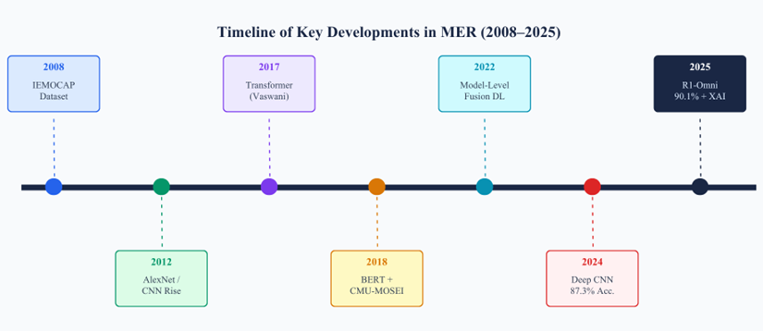
Fig 2.1 Timeline of Key Developments in Multimodal Emotion Recognition (2008–2025)
Fig 2.1 presents a chronological overview of the field, highlighting the key dataset releases, algorithmic breakthroughs, and benchmark performance milestones that define each era of MER research.
2.3 Transformer Era and Pre-trained Models (2018–2023)
The publication of the Transformer architecture [6] by Vaswani et al. in 2017 and BERT by Devlin et al. in 2018 inaugurated a new paradigm in natural language processing that rapidly propagated to multimodal emotion recognition. Pre-trained Transformer models, fine-tuned on emotion-labelled data, substantially outperformed LSTM-based text encoders on utterance-level emotion classification. Tripathi et al. [9] demonstrated that combining BERT-derived text embeddings with speaker-recognition transfer learning for audio yielded a strong multimodal baseline.
Concurrently, the CMU-MOSEI dataset [8] extended multimodal emotion research to a much larger scale (23,453 utterances), enabling training of deeper models and more rigorous cross-modal attention mechanisms. Cross-modal attention allows a model to selectively attend to features from one modality while conditioning on the context of another — for example, attending to relevant facial regions while processing specific words in a transcript. Poria et al. [3][7] provided comprehensive surveys of these developments, cataloguing the taxonomy of fusion strategies and benchmark results.

2.4 State of the Art: XAI and Reinforcement Learning (2024–2025)
The most recent phase of MER research is characterised by two converging trends: the push for explainability and the integration of reinforcement learning. Zhang et al. [2] demonstrated that a deep CNN with late fusion achieved 87.3% accuracy on RAVDESS in 2024, confirming the continued competitiveness of CNN-based approaches even in the Transformer era. The R1-Omni system [5] represented a qualitative leap, achieving 90.1% on IEMOCAP while generating natural-language explanations for each emotion prediction via chain-of-thought reasoning — a capability with profound implications for clinical and legal deployments where model transparency is paramount.
Table 2.1 summarises the comparative performance of key research contributions discussed in this chapter, ordered chronologically.
Table 2.1 Chronological Comparison of Key MER Research Contributions
Authors / System | Modalities | Model | Dataset | Best Acc. | Year
Poria et al. [4] | Audio + Video + Text | Model-Level Fusion DL | IEMOCAP | 76.5% | 2022
Wang et al. [1] | Audio + Video + Text | Survey / CNN+LSTM | Multiple | — | 2023
Poria et al. [7] | Speech + Text + Face | Survey / CNN+BERT | Multiple | — | 2023
Zhang et al. [2] | Audio + Video | Deep CNN Late Fusion | RAVDESS | 87.3% | 2024
R1-Omni [5] | Audio + Video + Text | RL + Omni VLM + XAI | IEMOCAP | 90.1% | 2025

2.5 Comparison and Inferences
The survey reveals a consistent pattern: each technological generation improves upon its predecessor primarily through two mechanisms — richer feature representations and more expressive fusion strategies. Hand-crafted features gave way to CNN-learned representations; shallow classifiers gave way to deep recurrent and attention-based models; unimodal pipelines gave way to tightly coupled multimodal architectures. The inference drawn is that the performance ceiling of any given modality is best overcome not by further improving that modality in isolation, but by introducing complementary signals and learning to dynamically weight their contributions.

CHAPTER 3
DISCUSSION OF TECHNOLOGY
This chapter provides a detailed technical discussion of the core technologies that constitute a modern Multimodal Emotion Recognition system. The discussion is organised around the three principal stages of the MER pipeline: (i) feature extraction from individual modalities, (ii) fusion of extracted features across modalities, and (iii) the deep learning models employed at each stage. Where relevant, algorithmic formulations are presented to provide mathematical rigour.
3.1 Feature Extraction Techniques
Feature extraction is the process by which raw, high-dimensional sensor data is transformed into a compact, discriminative representation suitable for downstream classification. The extraction strategy differs substantially across modalities, reflecting the inherent structure of each signal type.
Audio Feature Extraction
Mel Frequency Cepstral Coefficients (MFCCs) are the most widely used audio features in MER. They capture the short-term power spectrum of speech in a perceptually motivated frequency scale, mimicking the non-linear frequency resolution of the human auditory system. Complementary features include the spectrogram (a time-frequency representation), pitch contour, energy, zero-crossing rate, and chroma features. The OpenSMILE toolkit provides a standardised feature set of up to 6,373 acoustic features used extensively in the MER literature [7].
More recently, wav2vec 2.0 — a self-supervised Transformer model pre-trained on large quantities of unlabelled speech — has demonstrated superior performance over hand-crafted features by learning contextualized acoustic representations directly from raw audio waveforms. As shown in Fig 3.1, the MFCC spectrogram provides a rich visual representation of the time-frequency structure of an emotional utterance.
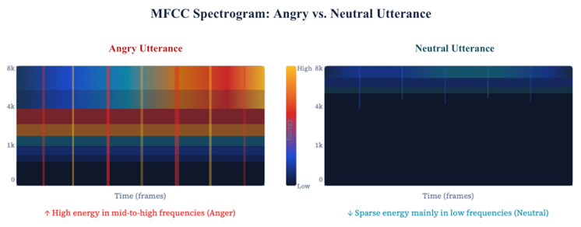
Fig 3.1 MFCC Spectrogram of an Emotional Speech Utterance (Anger vs. Neutral)
As can be seen in Fig 3.1, utterances expressing anger exhibit a characteristically higher energy distribution in the mid-frequency bands compared to neutral speech, providing a discriminative cue exploited by audio-based classifiers.
Video Feature Extraction
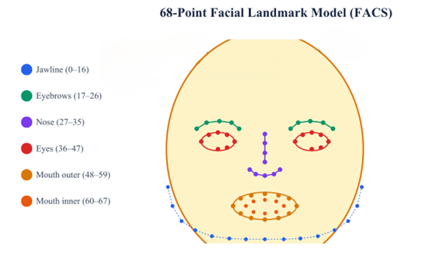
Visual emotion cues are extracted primarily from facial expressions, using either the FACS system of Action Units (AUs) or deep CNN-learned features. Histogram of Oriented Gradients (HOG) descriptors capture local shape and texture information, while 3D facial landmarks (68-point models) track the geometric deformation of facial regions across frames. Gaze direction and head pose are additional cues that correlate with specific emotional states, particularly attention and avoidance behaviours [3]. Fig 3.2 illustrates the 68-point facial landmark model used in standard video-based MER pipelines.

Fig 3.2 68-Point Facial Landmark Model for Action Unit Detection

Text Feature Extraction
Text-based emotion recognition relies on semantic representations of speech transcripts. Classical approaches used TF-IDF weighting and n-gram features fed to SVMs or logistic regression classifiers. Contemporary systems use contextual embeddings from BERT or its variants (RoBERTa, DistilBERT, ALBERT), which encode not merely the meaning of individual words but their semantic role in the full utterance context. Eq. 3.1 expresses the softmax operation used to convert raw logit scores from the emotion classifier into probability distributions over emotion categories.
Π(l,τ)(aⱼ) = exp(P(l,τ)(aⱼ)) / Σᵦ exp(P(l,τ)(aᵦ)) (3.1)
As described by Eq. 3.1, the softmax normalisation ensures that the predicted emotion probabilities across all A emotion classes sum to unity, providing a well-calibrated posterior distribution over emotion labels.

3.2 Fusion Techniques
Fusion is the mechanism by which information from multiple modalities is combined. Three principal fusion paradigms exist in the MER literature, each with distinct architectural implications and performance trade-offs.
Early Fusion
In early fusion (feature-level fusion), raw or extracted features from all modalities are concatenated into a single high-dimensional vector before being passed to a unified classifier. The advantage of this approach is that the classifier can learn shared cross-modal representations; however, the high dimensionality of the concatenated feature vector increases computational cost and may introduce noise from less informative modalities. Fig 3.3 illustrates the architecture of an early fusion MER system.
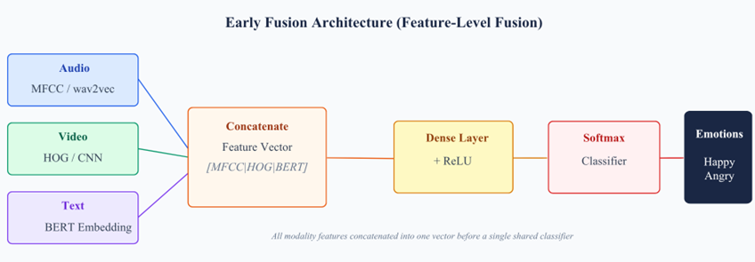
Fig 3.3 Early Fusion Architecture: Feature-Level Concatenation Before Classification
Late Fusion
Late fusion (decision-level fusion) trains an independent classifier for each modality and combines their output scores or predicted labels using a voting, averaging, or learned weighting scheme. This approach gracefully handles missing modalities — if one modality is unavailable, the remaining classifiers still produce valid predictions. Zhang et al. [2] demonstrated that a deep CNN with late fusion of audio and video streams achieves 87.3% accuracy on RAVDESS, underscoring the effectiveness of this approach.
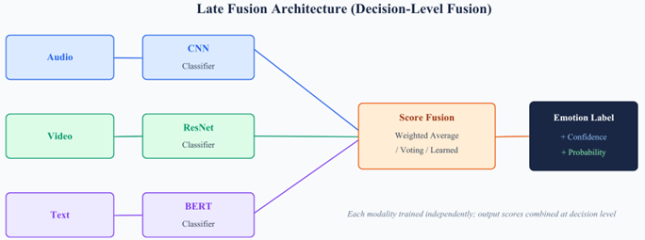
Fig 3.4 Late Fusion Architecture: Independent Modality Classifiers with Score Combination

Hybrid Fusion with Cross-Modal Attention
Hybrid fusion combines elements of both early and late fusion, using cross-modal attention mechanisms to dynamically weight the contribution of each modality at intermediate representation layers. The cross-modal attention score between modality A and modality B is given by Eq. 3.2, where Q, K, and V are the query, key, and value projections respectively.
Attention(Q, K, V) = softmax(QKᵀ / √dₖ) · V (3.2)
As expressed in Eq. 3.2, the scaling factor √dₖ prevents the dot-product similarity scores from growing excessively large in high-dimensional spaces, which would saturate the softmax and yield near-zero gradients. Hybrid fusion with attention yields the best empirical results on standard benchmarks [5], as reflected in Table 3.1.
Table 3.1 Comparison of Fusion Strategies in Multimodal Emotion Recognition
Fusion Type | Pros | Cons | Typical Accuracy Range
Early | Shared representation learning | High dimensionality, noise-prone | 72–80%
Late | Handles missing modalities | Loses inter-modal correlations | 75–87%
Hybrid | Best accuracy, context-aware | Complex design, high compute | 80–90%+

3.3 Deep Learning Models
The feature extraction and fusion stages described above are implemented using a variety of deep learning architectures. CNN layers serve as efficient local feature extractors for spectrograms and video frames. LSTM networks model the temporal dynamics of sequential emotional signals. Transformer-based encoders (BERT, wav2vec 2.0, ViT) provide global context through self-attention, and constitute the backbone of current state-of-the-art systems [4][7]. Fig 3.5 presents the complete end-to-end MER pipeline integrating all three model families.
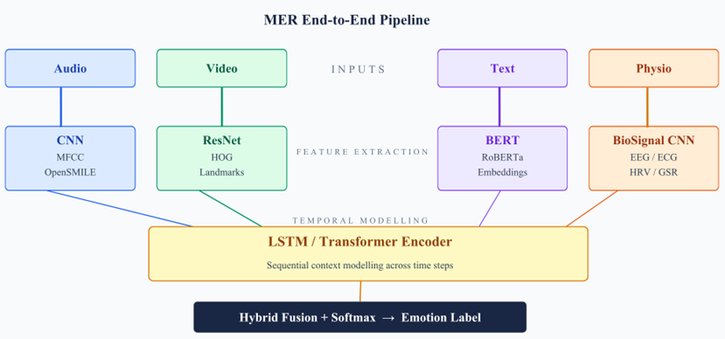
Fig 3.5 End-to-End MER Pipeline: Feature Extraction, Fusion, and Classification
3.4 Explainable AI in MER
A significant limitation of deep learning-based MER systems is their opacity: it is difficult to determine which input features or modalities drove a particular emotion prediction. This is a critical concern in high-stakes applications such as clinical depression screening or legal testimony analysis. XAI techniques such as SHAP (SHapley Additive exPlanations) values and Grad-CAM (Gradient-weighted Class Activation Mapping) address this by attributing prediction scores to individual features and spatial image regions respectively [5][7]. The R1-Omni model advances this further by generating chain-of-thought rationale text for each prediction.

CHAPTER 4
IMPACT ON SOCIETY, ENVIRONMENT AND DOMAIN
Multimodal Emotion Recognition is not merely a technical achievement — it carries substantial implications for society, the environment, and the domain of human-computer interaction. This chapter examines these impacts critically, considering both the transformative benefits that MER can deliver and the ethical, environmental, and societal challenges it raises. The analysis is structured across three dimensions: societal impact, environmental impact, and domain-specific impact.
4.1 Impact on Society
The most immediate societal impact of MER lies in the domain of healthcare and mental health. Depression, anxiety, and post-traumatic stress disorder (PTSD) are among the most prevalent and underdiagnosed conditions worldwide. Passive, continuous monitoring using MER systems embedded in wearable devices or smartphones could enable early detection of emotional deterioration, providing timely alerts to clinicians and caregivers [8]. Mental health chatbots augmented with MER capabilities can adapt their responses based on the detected emotional state of the user, delivering more empathetic and effective support.
In education, emotion-aware adaptive learning systems can detect student engagement, confusion, and frustration in real time, adjusting the difficulty and pace of instructional content accordingly. This has the potential to personalise education at scale — a long-sought goal in the field of intelligent tutoring systems. However, these societal benefits must be weighed against serious concerns around privacy, consent, and the potential for discriminatory or manipulative use of emotion data [3].
4.2 Impact on Environment
The environmental impact of MER is primarily associated with the computational cost of training large multimodal deep learning models. State-of-the-art Transformer-based MER systems require significant GPU resources for training, contributing to substantial carbon emissions. Strubell et al. estimated that training a single large NLP model can produce carbon emissions equivalent to five times the lifetime emissions of an average automobile [9]. The trend towards ever-larger multimodal models amplifies this concern.
Mitigating strategies include the use of model compression techniques (pruning, quantisation, knowledge distillation) to produce lightweight models suitable for edge deployment, thereby reducing the energy cost of inference. The development of TinyBERT and MobileNet variants for MER represents an important step in this direction, enabling emotion recognition on low-power wearable devices without cloud connectivity.
4.3 Impact on the Domain of HCI and AI
Within the domain of HCI and AI, MER is driving a fundamental redefinition of the human-machine interface. Emotion-aware systems can adapt their behaviour, tone, and information presentation to the detected emotional context of the user — a capability that moves interaction paradigms from command-response to genuinely conversational and empathetic exchanges [1]. In autonomous vehicles, real-time MER enables driver drowsiness and stress monitoring, with direct implications for road safety. In social robotics, MER endows robotic companions with the ability to recognise and respond to human emotional states, improving acceptance and effectiveness in elderly care settings.
Fig 4.1 illustrates the deployment of MER in a healthcare monitoring workflow, demonstrating how multimodal emotion signals are captured, processed, and acted upon.
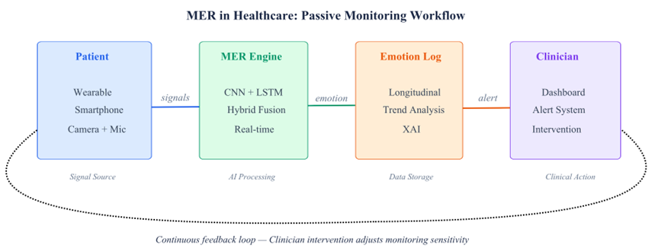
Fig 4.1 MER Deployment in a Healthcare Passive Monitoring Workflow
As depicted in Fig 4.1, the integration of MER into continuous passive monitoring systems creates a feedback loop between the patient's emotional state and clinical decision support tools, enabling proactive rather than reactive mental health interventions.
4.4 Ethical Considerations
The deployment of MER systems raises profound ethical questions. Emotion recognition models trained predominantly on Western, English-speaking datasets may fail to generalise across cultures where the expression and interpretation of emotion differ significantly. This cross-cultural gap risks perpetuating or amplifying existing biases if deployed globally without adequate localisation. Furthermore, the use of emotion data in commercial contexts — for example, to infer consumer sentiment or employee productivity — raises questions of consent, data ownership, and the potential for coercive surveillance [5]. Regulatory frameworks such as the European Union's AI Act are beginning to address these concerns, classifying emotion recognition in sensitive contexts as high-risk AI.
CHAPTER 5
CONCLUSION & FUTURE WORK
This seminar has presented a comprehensive examination of Multimodal Emotion Recognition using deep learning and fusion techniques. From its conceptual foundations in Affective Computing to the most recent reinforcement learning-based XAI systems, the field has undergone a remarkable transformation driven by advances in deep learning, large-scale annotated datasets, and increasing computational resources.
5.1 Conclusion
The principal conclusion of this study is that multimodal fusion consistently and substantially outperforms unimodal approaches to emotion recognition, both in terms of accuracy and robustness to real-world signal degradation. CNN, LSTM, BERT, and Transformer architectures each contribute distinct and complementary capabilities to the MER pipeline, and their combination through hybrid fusion with cross-modal attention currently represents the state of the art. The R1-Omni system [5], achieving 90.1% accuracy on IEMOCAP with integrated chain-of-thought explanations, exemplifies the direction in which the field is moving — towards systems that are simultaneously more accurate, more transparent, and more computationally efficient.
Key challenges remain, however. The missing modality problem — the graceful handling of absent input channels at inference time — has not been fully resolved. Cross-domain generalisation, from controlled laboratory datasets to uncontrolled real-world environments, continues to limit practical deployment. Class imbalance in training data and the substantial computational cost of Transformer-based systems also represent active areas of research requiring further attention.
5.2 Future Scope
The future of MER lies at the confluence of several exciting research trajectories. Multimodal Large Language Models (MLLMs) such as GPT-4o and Gemini Ultra offer the prospect of zero-shot emotion understanding — the ability to recognise and reason about emotions without task-specific fine-tuning — by leveraging their vast pre-training on diverse multimodal data. Integrating MER capabilities natively into such foundational models could dramatically lower the barrier to deployment across diverse application domains.
Edge deployment of lightweight MER models in wearable devices and mobile platforms represents a critical frontier for the democratisation of emotion-aware technology, enabling applications in continuous mental health monitoring, adaptive assistive devices, and real-time human-robot interaction without dependence on cloud infrastructure. Simultaneously, the development of culturally adaptive MER systems — trained on geographically and demographically diverse datasets — is essential to ensure that the benefits of this technology are equitably distributed across global populations [6][9].
In summary, Multimodal Emotion Recognition stands at a pivotal juncture: the technical foundations are robust, the application domains are expansive, and the societal demand is growing. Sustained interdisciplinary research spanning machine learning, cognitive science, ethics, and human-computer interaction will be essential to realise the full potential of this transformative technology.

REFERENCES
[1] H. Wang et al., "A Review of Multimodal Emotion Recognition from Datasets, Preprocessing, Features, and Fusion Methods," Neurocomputing, 2023.
[2] Y. Zhang et al., "Deep CNN with Late Fusion for Real Time Multimodal Emotion Recognition," Expert Systems with Applications, 2024.
[3] S. Poria et al., "A Survey of Deep Learning-Based Multimodal Emotion Recognition: Speech, Text, and Face," Entropy, 2023.
[4] S. Poria et al., "Deep Learning based Multimodal Emotion Recognition using Model-Level Fusion of Audio–Visual Modalities," Knowledge-Based Systems, 2022.
[5] R1-Omni Team, "R1-Omni: Explainable Omni-Multimodal Emotion Recognition with Reinforcement Learning," 2025.
[6] J. Devlin et al., "BERT: Pre-training of Deep Bidirectional Transformers for Language Understanding," NAACL, 2019.
[7] D. Lian et al., "A Systematic Survey on Multimodal Emotion Recognition using Learning Algorithms," Intelligent Systems with Applications, 2023.
[8] J. Ma et al., "Multimodal Emotion Recognition Using Visual, Vocal and Physiological Signals: A Review," Applied Sciences, 2024.
[9] S. Tripathi et al., "Multimodal Emotion Recognition using Transfer Learning from Speaker Recognition and BERT-based Models," 2022.

